- Position Details
Title: Arborist and Browse Assistant
Reports to: Horticulture Manager
Location: Melbourne Zoo
Band: T1 - T3
Tenure: Ongoing
Employment Type: Full time

2. Context

Zoos Victoria operates world-class zoos on four sites: Melbourne Zoo, Healesville Sanctuary, Werribee Open Range Zoo and Kyabram Fauna Park. Our 2030 Strategy underpins all that we do and includes our moral purpose, values and key focus areas:



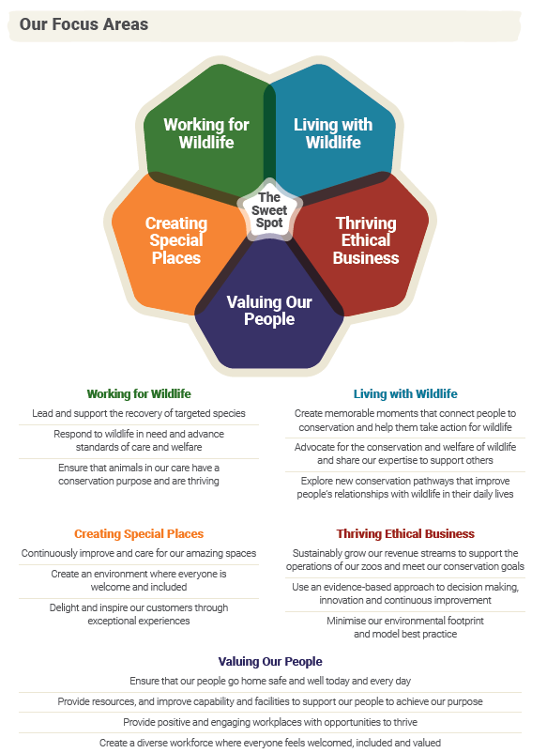

3. Purpose Statement

The Arboriculture / Browse Assistant position will provide support to the Arborist and Browse Officer in the delivery of Arboriculture safety risk mitigation work, day to day arboriculture activities and the ongoing daily collection of Browse material. They will work together to deliver effective and efficient tree management and browse standards whilst shaping and positively contributing to a supportive and passionate team culture aligned to ZV’s values and objectives.

4. Reporting Lines

5. Accountabilities

Accountability | Measurement Criteria
Leadership | Demonstrate behaviours in accordance with ZV Values and act as a positive role model for staff.  Actively collaborate with colleagues to achieve planned outcomes.
Safety | Work within the safety guidelines supported by JSEA’s SOP’s  Encourage a speak up culture.  Report incidents within 24 hours of occurrence.  Actively monitor workplace to identify hazards and take appropriate action to rectify if hazards found.  Ensures that all relevant JSEA’s, injury, incident reports and other general permits are completed

6. Selection Criteria

Details | Essential
Qualifications | Certificate III Arboriculture  Chainsaw operator and tree felling certificates  First Aid level 2  EWP Operators certificate  Current Victorian Medium Rigid Truck drivers’ licence
Skills & Knowledge | Demonstrated knowledge of all elements of tree climbing, pruning, felling and tree waste removal  Demonstrated physical capacity to carry out all elements of the role  Ability to set and meet goals  Proven communication and interpersonal skills in developing and maintaining harmonious productive relationships with all stakeholders  Sound time management skills  Good written and verbal communication skills  Understanding and demonstrated commitment to OH&S & EEO principles and practices
Experience | Proven ability to deliver high standards of arboriculture with safety as a key element of operation

