- Position Details
Title: Keeper
Reports to: Life Sciences Manager
Band: T

2. Context

Zoo Victoria operates world-class zoo on three sites: Melbourne Zoo, Healesville Sanctuary and Werribee Open Range Zoo. Our 2030 Strategy underpins all that we do and includes our moral purpose, values and key focus areas:
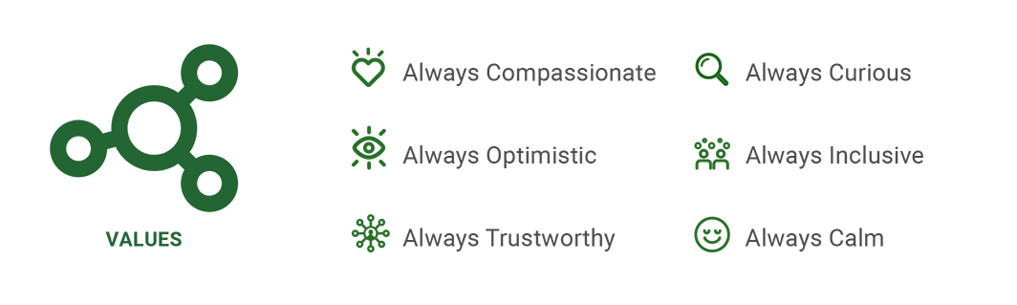
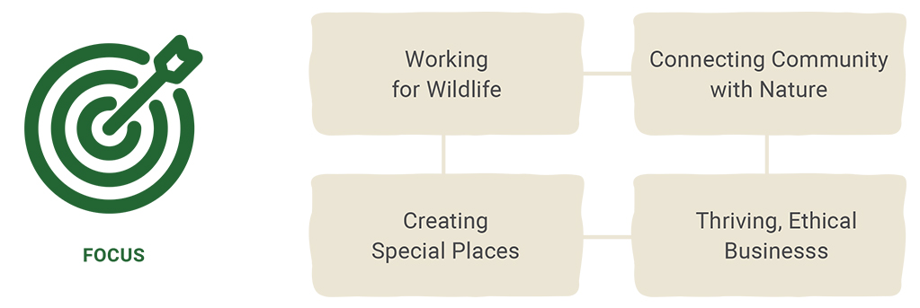

3. Purpose Statement
Band T is the Trade Level for Zoo Keepers, who have successfully completed the Certificate III Captive Animal Management (or an equivalent level through formal process of recognition of prior learning) and with a minimum of three years on the job zoo keeping experience.

Movement through the Band is achieved through demonstrated proficiency in knowledge of zoo keeping and zoos philosophies with evaluation through a ZV evidence based appraisal system. The Band T Keeper is responsible for the provision of husbandry requirements for a range of collection animals, to work within a team of Keepers made up of staff with backgrounds in the husbandry of the different taxa.

The Band T Keeper may also be allocated specific areas of responsibility within the Animal Department. The responsibilities include animal welfare, animal training, behavioural enrichment, animal records, staff development, staff training/supervision, OH&S, conservation, management development, specialist animal skills and other projects. Under the direction of the Precinct/Life Sciences Manager, the Band T Keeper position assists with the development and implementation of new and innovative programs, training and inspiring staff to embrace new philosophies as part of a crossfunctional team to meet the key priorities in the Zoos Victoria Strategic and ZV Corporate Plans

4. Reporting Lines

5. Accountabilities

Animal Husbandry

Delivers efficient and effective animal husbandry that enhances the management of the Animal Division whilst assisting in delivering outcomes of the Strategic Plan.

- Animal Welfare – demonstrated understanding of Animal Welfare Code. Assess and apply best practice husbandry to monitor and maintain animal wellbeing providing appropriate documentation and reporting.

- Breeding & Reproduction – monitor and respond to breeding animal requirements; prepare and implement breeding action plans for several taxa.

- Capture & Restraint – lead best practice capture & restraint for multiple taxa for introductions and transfers.

- Animal Behaviour – knowledge of the behaviour and husbandry of a broad range of taxa, with the ability to apply and monitor strategies, and suggest ways to improve welfare. . Able to recognise signs of abnormal health and/or behaviour of relevant species and take appropriate action.

- Animal Health Care – assist with delivery of medical treatments to animals as directed by veterinarians; understand and follow quarantine and zoonotic disease prevention protocols. Maintain standards of hygiene for yourself and animals.

- Animal Dietary Needs – develop daily feeding rounds, with the ability to prepare and present advanced dietary requirements for differing behavioural and physiological needs of animals. Knowledge of appropriate browse species and delivery for required species.

- Collection Management – Knowledge in ZV species selection tool, and the need for sustainable animal collections; ability to interpret species management documents.

- Animal Environment
Demonstrates best practice principles to ensure the animals environment supports their welfare whilst delivering the vision of the property and meeting the needs of our visitors
- Animal Enclosures – develop and implement appropriate rounds ensuring appropriate cleaning regimes, rodent management, enclosure maintenance, operations and security, exhibit presentation and renovations. Participate in planning exhibit and enclosure design . Identify weed species and remove.
- Animal Enrichment – develop, implement, document, monitor and review animal enrichment programs.
- Training & Conditioning – develop, implement, document and maintain effective conditioning/training programs for different species of animals.
- Strategic Animal Management – awareness of the balance required between animals and the requirements of the business; whilst contributing to achieving world’s best practice for captive animals.
- Wildlife Response – respond to wildlife in need including; impact assessments, rescue and rehabilitation of native wildlife following procedures and protocols.

Administration

Animal Records & Information – Maintain accurate animal records; understand regional and global animal record keeping systems. Ability to access, analyse and retrieve records using animal keeping information systems and software. Uses and provides information for ZV AIMS. Place orders through Workplace as required.

- General Requirements

- Health & Safety - actively contributes to safety at ZV by being aware of the safety policies and procedures and consciously acknowledge them every day thus ensuring that ZV is a safe place to work.
- Participate in H&S assessments and development of SOP’s. Perform duties of Safety Warden if required.
- Work according to standard operating and safety procedures
- Report and remove unsafe equipment or unsafe work procedures
- Report hazards/ incidents within 24 hours of occurrence
- Train (where required) and assist other staff with reporting of hazards/incidents
- Actively monitor workplace to identify hazards and take appropriate action to rectify if hazards found.

- Team / Communication - maintain effective communication within the team and with key stakeholders

- Comply with zoo policies and procedures as a performance issue.
- Participate in team building strategies.
- Ensure effective communications within the section, and with other sections/departments as per appropriate communication channels.
- Effectively contribute to team performance and the daily operations.
- Comply with precinct administrative and management processes

- Visitor Experience – actively engage our visitors through the provision of experiences that inspire and facilitate conservation action.
- Community Conservation - support implementation of agreed Wildlife Conservation and Science Programs and Community Conservation Programs
- Develop and deliver engaging presentations appropriate to audience, including keeper talks and visitor/animal encounters, special tours, and commercial products.
- Participate in media and Public Relations events.
- Personal development
- Contribute to the delivery of staff and team goals, by actively attending to your own professional development.
- Participate in performance appraisals/Zoo Employee Performance Plans (ZEPP).
- Work according to prescribed performance standards.
- Contribute to the development, implementation and delivery of staff and team performance standards.
- Comply with organisation policies. Contribute to updating or implementing new policies. Comply with legislative requirements.
- Undertake training courses as required. Assist in the training of new staff.
- Participate in the pre-appraisal assessment of less qualified keepers.
- Conservation & Science
Engage in the conservation efforts of Zoos Victoria, thereby contributing to the delivery of tangible conservation outcomes

- Conservation – knowledge of ZV conservation programs and campaigns.
- Understanding of biodiversity conservation, knowledge and experience of field research techniques.
- Understanding of the integrated approach taken to delivery of successful Recovery programs.
- Understanding of the ZV advocacy role and use of Ambassador Species.
- Science – knowledge of ZV Research programs and research processes.
- Experience working in a scientific framework by applying scientific principles to animal management and research programs

- Safety
- Work within the Safety Circle
- Encourage a speak up culture
- Report incidents within 24 hours of occurrence
- Actively monitor workplace to identify hazards and take appropriate action to rectify if hazards found

6. Selection Criteria

Details | Essential
Qualifications | - Minimum requirement - Certificate III Captive Animals (or equivalent)
Skills & Knowledge | - Ability to represent the interests of Zoos Victoria in all areas related to captive animal management, husbandry, welfare and conservation  - Demonstrated commitment to developing and implementing animal enrichment, training/conditioning and visitor interaction programs.  - Take accountability for implementing husbandry techniques.  - Strong ability to be flexible in order to meet changing project requirements.  - Demonstrated commitment to follow Zoos Victoria Strategic & Corporate Plans, including support of the five action areas – conservation, animals, people, visitors and financial sustainability  - Proficient in using MS Office, including word-processing, excel and database packages.  - Ability to work within budgets.
Experience | - A minimum of three years’ experience as an animal keeper encompassing a broad range of experience across a variety of animal taxa.  - Proven commitment and ability in assisting with staff supervision, career development and staff training.  - Ability to develop and implement projects that define key performance indicators for staff.  - Ability to foster and develop staff expertise in specific taxonomic disciplines  - Ability to implement effective work practices that adhere to Health & Safety standards and other relevant legislative requirements.  - Experience in animal reproductionand knowledge of raising captive animals and proven ability to balance animal welfare needs with the objectives of Zoos Victoria.  - Experience delivering presentations/public speaking before a mixed general audience.  - Demonstrated excellence in both verbal and written communication skills.
Other Requirements | - An Employee Status Working with Children Check  - Up to date COVID-19 vaccination status

