1. Position Details

Title: Life Sciences Manager - Animal Health

Reports to: Senior Manager, Animal Care & Conservation

Location: Melbourne Zoo

Band: 6

Employment Type: Full-time

##### 2. Context

Zoo Victoria operates world-class zoo on four sites: Melbourne Zoo, Melbourne Zoo, Kyabram Fauna Park and Werribee Open Range Zoo. Our 2030 Strategy underpins all that we do and includes our moral purpose, values and key focus areas:



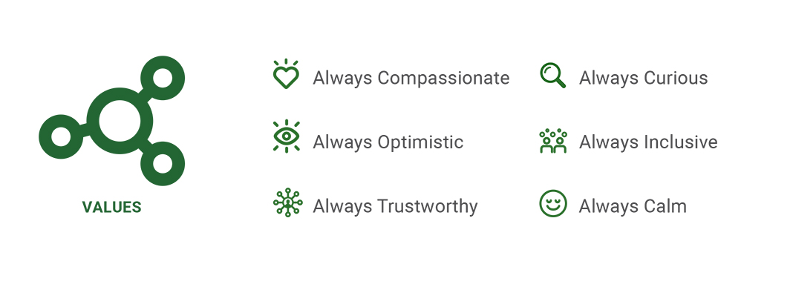

Our Focus Areas

Working for wildlife 
- Lead and support the recovery of targeted species
- Respond to wildlife in need and advance standards of care and welfare
- Ensure that animals in our care have a conservation purpose and are thriving
Living with wildlife
- Create memorable moments that connect people to conservation and help them take action for wildlife
- Advocate for the conservation and welfare of wildlife and share our expertise to support others
-Explore new conservation pathways that improve people's relationships with wildlife in their daily lives
Creating special places
- Continuously improve and care for our amazing spaces
- Create an environment where everyone is welcome and included
-Delight and inspire our customers through exceptional experiences
Valuing our people
- Ensure that our people go home safe and well today and every day
- Provide resources, and improve capability and facilities to support our people to achieve our purpose
-Provide positive and engaging workplaces with opportunities to thrive
-Create a diverse workforce where everyone feels welcomed, included and valued
Thriving ethical business 
- Sustainably grow our revenue streams to support the operations of our Zoos and meet our conservation goals
-Use an evidence-based approach to decision making, innovation and continuous improvement
-Minimise our environmental footprint and model best practice 
All this makes the sweet spot

**3. Purpose Statement**

The Life Sciences Manager (LSM) - Animal Health is a key leadership role responsible for overseeing the management of the Melbourne Zoo Animal Health Team. As a member of the Senior Leadership team at Melbourne Zoo, the LSM plays a crucial role in shaping the strategic development of the organisation. As a vital member of our team, the LSM will exhibit strong leadership qualities, strategic thinking, and a passion for animal welfare and conservation. They will contribute to the continued success of our organisation by driving positive change and ensuring the highest standards of operational excellence.

In addition to ensuring animal health, welfare and wildlife management are aligned with World’s best practices, the LSM will demonstrate strong leadership skills to drive a culture of excellence and continuous improvement. This includes maximising the quality of the visitor experience, realising the conservation vision of Zoos Victoria and optimising operational efficiency.

The LSM will be responsible for cultivating and leading a high-performance team that fosters open and effective communication. Collaborating with the Senior Veterinarian, The Vet Hospital Supervisor, and the MRU Strategic Response Coordinator, the LSM will establish animal care standards and develop a comprehensive medicine program, which the animal health team will then deliver and implement.

The LSM will also be responsible for department management including resourcing, budgeting, rostering oversight, administration, planning, veterinary and compliance reporting, and risk management. ~~and education programs that increase public understanding of wildlife conservation.~~

**4. Reporting Lines**

**5.Accountabilities**

|  |
| --- |
| **Leadership**  * Demonstrates positive behaviours and coaches staff in the competencies (behaviours) essential to effective leadership * Assists in the development of leadership opportunities and continuing education to optimise staff commitment and performance. * Lead the staff to ensure a high level of service to keepers, managers, zoo visitors, wildlife carers, external veterinary practices and people who rescue wildlife. * Develop, implement and deliver staff and team performance standards, plan and eZepps. * Build a strong, skilled team, capable of delivering the veterinary management objectives for the property. * Ensure a team culture that is supportive and participates in a process of continuous improvement. * Actively contribute to the Life Sciences Management Team and represent the veterinary teams interests on a strategic level. * Develop and implement team building strategies. * Appropriately plan and manage the workforce using Time2Work. |
| **Departmental Management**  * Manage the Veterinary Department to meet all institutional management requirements in an efficient and timely manner * Manage departmental recurrent budget and allocated capital funds * In consultation with the Senior Vet, review, recommend and implement appropriate structures, reviews and protocols as required for the delivery of world’s best practice veterinary services throughout Melbourne Zoo * Ensure that the MZ Vet Department facilities are developed and maintained efficiently and effectively in accordance with corporate policies and best sustainable management practice. * Administration of the MZ Veterinary department including procurement, staff rostering and scheduling of equipment maintenance etc. * Ensure that the Veterinary Department is staffed with an appropriately qualified, competent and motivated workforce, consistent with Zoos Victoria’s objectives for efficiency, commitment, enthusiasm, culture and change * Set effective work practices that adhere to Equal Employment Opportunities and other legislative requirements. * Identify key successors, develop and implement development plans * Assist in improving the effectiveness of Veterinary services across Zoos Victoria sites * With the Senior Vet and Vet Hospital Supervisor, set high standards of animal care at Melbourne Zoo and ensure delivery of these objectives by the Veterinary Team * Support the Senior Veterinarian in the identification, planning and publishing research activities and projects consistent with Zoos Victoria’s conservation and collection development strategies. * Facilitatea team-based approach to case management and animal welfare by the veterinary team * Formulate responsive and preventative medicine programs including biosecurity plans and quarantine protocols and deliver via the veterinary team |
| **Regulatory compliance**   * Ensure institutional compliance with regulatory requirements including the Veterinary Act, Quarantine Act, Prevention of Cruelty to Animals Act and the need to report notifiable diseases. * Provide assistance to Department of Environment, Land, Water and Planning (DELWP) and Victoria Police as required. * Ensure that the Veterinary database/ ZIMS records are completed for submission on rehabilitated animals annually * Responsible, with the Senior Veterinarian, for the control, process of use, access, to all restricted and other prescription drugs (Drugs and Poisons Regulation). * Ensure compliance with Department of Health legislation pertaining to radiation safety and monitoring |
| **Departmental Animal Care Objectives**   * Support the Senior Veterinarian and Vet Hospital Supervisor to lead the department to deliver high standard animal health care. * Together with the Senior Veterinarian & Vet Hospital Supervisor plus other Life Sciences Managers ensure optimal levels of animal welfare |
| **Projects**   * Participate actively in the planning and development of Melbourne Zoo and in setting organisational goals, including the development and implementation of organisational long range plans. * Liaise with Senior Veterinarian regarding annual minor works budget and capital expenditure needs |
| **Strategy**  * Contribute actively to the strategic and innovative development of Zoos Victoria and Melbourne Zoo |
| **Administration and Reporting**  * Produce timely and relevant administration reports and tasks (rostering, ordering, budgeting) for key external and internal stakeholders thus ensuring efficient process, record keeping and accountability. |
| **Safety**   * Work within the Safety Circle * Ensure that staff are coached to work within the Safety Circle * Encourage a speak up culture * Report incidents within 24 hours of occurrence * Actively monitor workplace to identify hazards and take appropriate action to rectify if hazards found |

**6. Selection Criteria**

|  |  |
| --- | --- |
| Details | Essential |
| Qualifications | * Tertiary qualifications in Leadership, Business Management or similar field (highly desirable) or equivalent experience * Tertiary qualifications in Veterinary Sciences will be highly regarded. |
| Skills & Knowledge | * Proven ability to lead in a dynamic and changing environment. * Ability to set departmental, sectional and individual goals ensuring corporate goals are met and to gain positive commitment from staff to achieve these. * Proven communication and interpersonal skills in developing and maintaining harmonious and participative staff relationships. * A passion for the role of zoos in providing world leading wildlife experience, education, conservation and research in a changing and complex environment. * Ability to integrate animal management functions and activities into visitor experience programs. * Understanding of the interrelationship between animal care, visitor needs, and conservation/research programs. * An ability to monitor and modify work flows within a complex team, in such a way that all staff feel supported, trusted and empowered to do their jobs at all times * Ability to explain and integrate operational, financial and administrative issues. |
| **Experience** | Essential   * Demonstrated experience in managing people, strong leadership skills, able to develop a unified team spirit and be an agent for organisational change. * Experience in a leadership or management role in a complex and resource constrained environment. * Demonstrated ability to establish and communicate a big “picture” vision and motivate a team to achieve this vision. * Experience in leading cultural change and commitment to creating a ‘learning department’. * The ideal candidate will have experience in the successful management and leadership of a cross functional team, which includes setting and managing a budget. * Excellent communication and public relations skills. * Proven experience in coaching and mentoring staff is desired. * Experience in practicing veterinary medicine will be highly regarded |
| **Other Requirements** | * A current Employee status Working with Children’s Check card * A current driver’s licence is essential. While the position is based at Melbourne Zoo, the ability to travel to all three zoo properties for work purposes is required * National Police Check |