1. Position Details

Title: Veterinary Administration Assistant

Reports to: Life Sciences Manager, Animal Health

Location: Melbourne Zoo

Band: 2

Tenure: Ongoing

Employment Type: Part-Time *0.7FTE (One weekend day each week required)*

##### 2. Context

Zoo Victoria operates world-class zoo on four sites: Melbourne Zoo, Healesville Sanctuary, Werribee Open Range Zoo and Kyabram Fauna Park. Our 2030 Strategy underpins all that we do and includes our moral purpose, values and key focus areas:





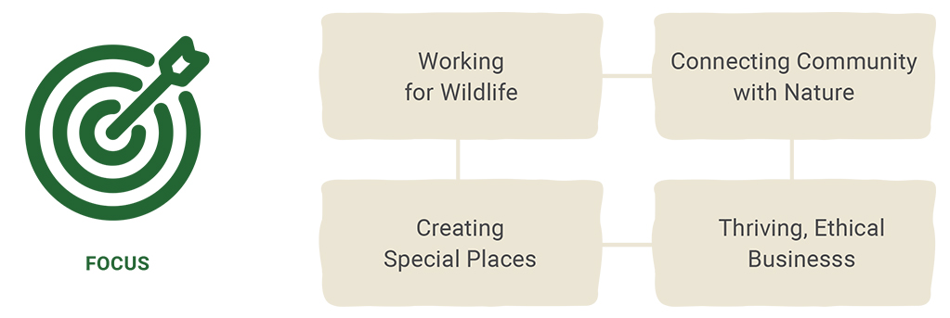

**3.** **Purpose Statement**

This position assists and supports the staff of the MZ Animal Health Department (Veterinary Team and Marine Response Unit) to ensure effective daily operations through high level administration, records and stock management, and internal and external communications.

**4. Reporting Lines**

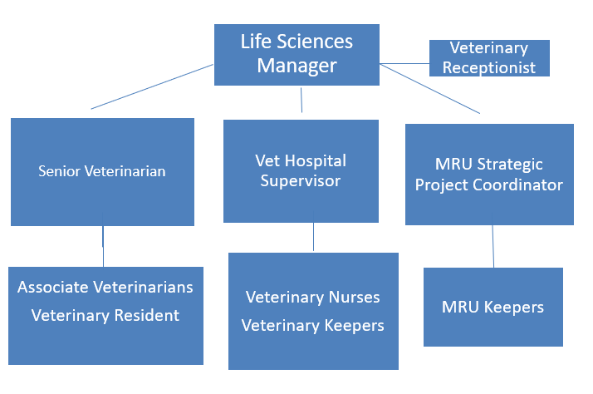

**5.Accountabilities**

|  |
| --- |
| **Accountability** |
| **Administration duties**   * Effectively liaise with life science staff, wildlife rehabilitators and other MZ visitors/customers as required with a high level of customer service regarding animals in hospital, in their care and in the community. * Provide accurate, timely and confidential administrative and organisational support to the Life Sciences Manager – Animal Health, Senior Veterinarian and Senior Vet Nurse, and MRU Strategic Project Coordinator. * Receptionist duties – greeting visitors, responding to queries, packaging samples, arranging animal transfers, and scheduling meetings * Coverage of MZ reception phone * Management of electronic files and folders – management of data entry into the medical record system (ZIMS) * Management of hard copy medical records and archiving. * Assist with purchasing and the administration of department finances including preparing purchase orders, obtaining quotes and managing invoices. * Stock management – manage and coordinate inventory (stationary and clinical supplies), ensure all office equipment is maintained and serviced as required. * Liaise with the MZ Volunteer Coordinator to manage volunteer placement, including weekly specimen runs * Assist in data collection on MZ and MRU case load and compiling this information into a user friendly format for use in cross property reports. Maintain Wildlife statistics database * Assist Life Sciences Manager to collate data, prepare & maintain Visual Management Board, reports, plans, presentations and audits. * Accurate minutes & records of meetings are maintained & disseminated appropriately. * Assist with accession and disposition of animals in ZIMS * Responsible for administrative induction of new staff and veterinary students * Responsible for maintenance and renewal of departmental radiation licences * Any other duties as reasonably requested by the Life Sciences Manager or associated MZ or ZV stakeholders. |
| **Health and Safety**   * Always work within the Safety Circle * Report accidents / incidents within 24 hours of occurrence * Actively monitor workplace to identify hazards and take appropriate action to rectify if hazards found. * Collate safety data and provide administrative support to the AWHC for logging safety concerns. |
| **Zoo People**   * Demonstrate expertise and professionalism in all interactions * Behave in accordance with the vision and values of Zoos Victoria * Communicate openly and honestly whilst respecting others * Actively contribute to the HS team and to ZV through effective cross functional engagement * Utilise effective problem solving strategies. |

**6. Selection Criteria**

|  |  |
| --- | --- |
| Details | Essential |
| Skills & Knowledge | * Proven communication and interpersonal skills, demonstrated ability to work effectively in a diverse team environment. * Demonstrated flexibility and ability to cope in a busy and high-pressure work environment. * Able to work unsupervised, sound problem-solving skills and initiative. * Proficient administrative ability with sound computer skills. |
| **Experience** | * A minimum of three years’ experience in a customer-facing role with relevant administration experience. * Demonstrated computer skills, particularly in records and database management with sound knowledge of all Microsoft Office programs. * Demonstrated verbal and written communication skills with a high level of attention to detail and accuracy. * Demonstrated time management skills and ability to manage competing priorities. * Demonstrated understanding of, and commitment to, safe work practices. * Experience with preparation and presentation of detailed reports. * Proven ability to develop effective and supporting relationships with colleagues.     Desirable:   * Experience working in an animal care or health care facility highly desirable * Understanding of, and a commitment to conservation. * Experience with medical, veterinary or zoological record and electronic procurement systems. |
| **Other Requirements** | * A current driver’s licence is required. * Flexible to work additional hours if required, this may include weekends and public holidays. |